**Final Year B. Tech., Sem VI 2022-23**

**cryptography and network security Lab**

**PRN No: 2019BTECS00071**

**Name: Charpale Abhishek Parmanand**

**Batch: B3**

**Assignment 1 : Caesar Cipher Encryption and Decryption**

**Aim:** To implement and develop the Caesar Cipher and to encryption and

decryption on the input plaintext

**Theory:**

* The Caesar Cipher technique is one of the earliest and simplest methods of encryption technique.
* It’s simply a type of substitution cipher, i.e., each letter of a given text is replaced by a letter with a fixed number of positions down the alphabet.
* The method is apparently named after Julius Caesar
* Encryption of a letter by a shift n can be described mathematically as  Encryption Phase  Decryption Phase

1. **Taking input from terminal :**

code :

#include<bits/stdc++.h>

#include<string.h>

using namespace std;

string encrypt(string text, int s)

{

string result = "";

for (int i=0;i<text.length();i++)

{

if(text[i] == ' ' || text[i] == '\n')

continue;

else if (isupper(text[i]))

result += char(int(text[i]+s-65)%26 +65);

else

result += toupper(char(int(text[i]+s-97)%26 +97));

}

return result;

}

string decrypt(string cipher,int s)

{

string result = "";

for(int i=0;i<cipher.size();i++)

{

if(cipher[i] == ' ' || cipher[i] == '\n')

continue;

else if (isupper(cipher[i]))

result += char((int(cipher[i]-s-65)+26)%26 +65);

else

result += char((int(cipher[i]-s-97)+26)%26 +97);

}

return result;

}

int main()

{

int choice;

int datachoice;

string sample;

int shift;

while(1)

{

cout << "Caesar Cipher\n 1. Encryption \n 2. Decryption\n 3. Exit\nEnter Choice: ";

cin>>choice;

if(choice>2 || choice <=0)

break;

switch(choice)

{

case 1:

cout<<"Enter data to be Encrypted:\n";

cin.ignore();

getline(cin,sample);

cout<<"Enter the shift value: ";

cin>>shift;

cout<<"Encrypted String:\n";

cout<<encrypt(sample,shift)<<endl;;

break;

case 2:

cout<<"Enter data to be Decrypted:\n";

cin.ignore();

getline(cin,sample);

cout<<"Enter the shift value: ";

cin>>shift;

cout<<"Decrypted String:\n";

cout<<decrypt(sample,shift)<<endl;;

break;

}

}

return 0;

}

Output:

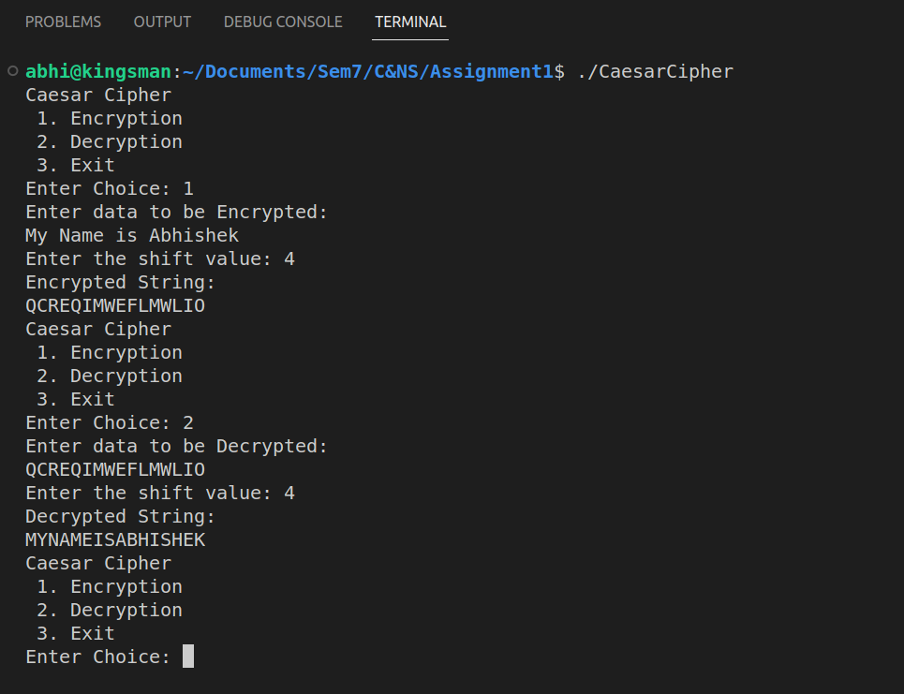

1. **Taking input from file :**

#include <bits/stdc++.h>

using namespace std;

string encrypt(string text, int s)

{

string result = "";

for (int i=0;i<text.length();i++)

{

if (isupper(text[i]))

result += char(int(text[i]+s-65)%26 +65);

else

result += char(int(text[i]+s-97)%26 +97);

}

return result;

}

string decrypt(string cipher,int s){

string result = "";

for(int i=0;i<cipher.size();i++){

if (isupper(cipher[i]))

result += char((int(cipher[i]-s-65)+26)%26 +65);

else

result += char((int(cipher[i]-s-97)+26)%26 +97);

}

return result;

}

int main()

{

#ifndef ONLINE_JUDGE

freopen("input.txt", "r", stdin);

freopen("output.txt", "w", stdout);

#endif

while(1){

// cout<<"\nChoose\n 1.Encryption \n2.Decryption \n using Caesar Cipher:- ";

int choice;

cin>>choice;

string text="SamplePlaintext";

int s = 3;

if(choice==1){

// cout<<"Enter the plain text:-";

cin>>text;

// cout<<"Enter the Key:-";/

cin>>s;

cout<<encrypt(text,s);

cout<<"\n\n\n";

}else if(choice==2){

// cout<<"Enter the cipher text:-";

cin>>text;

// cout<<"Enter the Key:-";

cin>>s;

cout<<decrypt(text,s);

cout<<"\n\n\n";

}else{

// cout<<"Program Terminated.\n";

break;

}

}

return 0;

}

Input file:

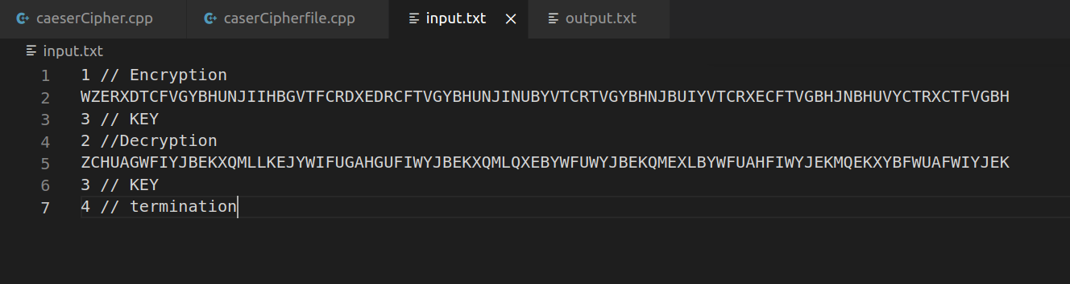

Output :

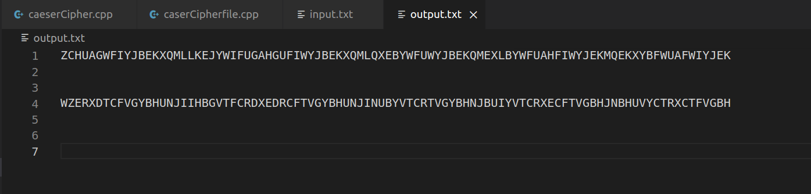

**Conclusion:**

Performed the experiment successfully. Encrypted the data

with the provided key. Output of this encryption is decrypted to match

the plaintext that was inputted by the user as shown in the above

diagram.